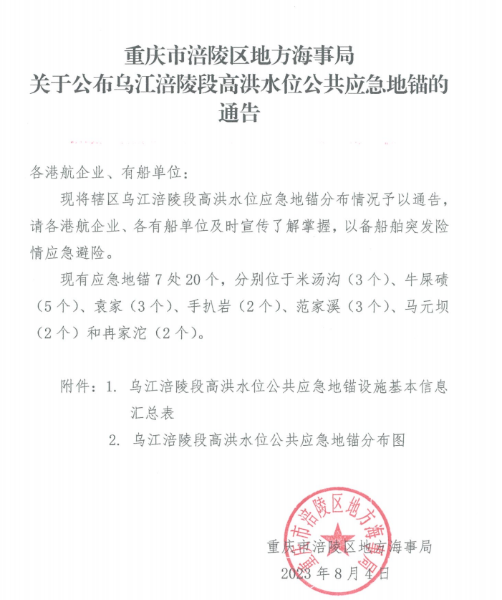

**附件1**

**乌江涪陵段高洪水位公共应急地锚设施基本信息汇总表**

|  |  |  |  |  |  |  |  |  |  |  |  |  |  |  |  |  |  |  |  |
| --- | --- | --- | --- | --- | --- | --- | --- | --- | --- | --- | --- | --- | --- | --- | --- | --- | --- | --- | --- |
| 序号 | 区县 | 建造年度 | 地锚所在位置 | 地锚名称 | 所在江河 | 岸别 | 距下游河口航道里程(千米) | 高程  (吴淞) | 经纬度 | | 地锚尺寸(米) | | | | | 系船设施 | | 设计锚泊能力(吨) | 备注 |
| 经度(度) | 纬度(度) | 长 | 宽 | | 高 | | 型式 | 直径  (毫米) |
| 1 | 涪陵 | 2023 | 牛屎碛 | 涪陵牛屎碛202301 | 乌江 | 左 | 5.5 | 165.10 | 107.39101 | 29.67525 | 4 | 4 | | 3 | | 锚链 | 38 | 3000 | 采用奥维互动地图经纬度 |
| 2 | 涪陵牛屎碛202302 | 5.5 | 165.10 | 107.39169 | 29.67597 |
| 3 | 涪陵牛屎碛202303 | 5.4 | 165.00 | 107.39276 | 29.67692 |
| 4 | 涪陵手扒岩202304 | 5.4 | 165.10 | 107.39341 | 29.67704 |
| 5 | 手扒岩 | 涪陵手扒岩202301 | 左 | 22.0 | 165.40 | 107.46491 | 29.57242 |
| 6 | 涪陵手扒岩202302 | 22.0 | 166.20 | 107.46447 | 29.57291 |
| 7 | 冉家沱 | 涪陵冉家沱202301 | 右 | 25.7 | 172.70 | 107.49497 | 29.55302 |
| 8 | 涪陵冉家沱202302 | 25.7 | 173.60 | 107.49450 | 29.55312 |
| 9 | 2015 | 范家溪 | 涪陵范家溪201501 | 右 | 22.57 | 165.32 | 107.46789 | 29.56985 | 4 | 4 | | 4 | | 46 |
| 10 | 涪陵范家溪201502 | 22.64 | 165.32 | 107.46719 | 29.57077 | 4 | 4 | | 4 | |
| 11 | 涪陵范家溪201503 | 22.72 | 165.32 | 107.4923 | 29.54761 | 4 | 4 | | 4 | |
| 12 | 涪陵 | 2015 | 牛屎碛 | 涪陵牛屎碛201501 | 乌江 | 左 | 5.01 | 165.14 | 107.38984 | 29.67986 | 4 | | 4 | | 4 | 锚链 | 46 | 3000 | 采用奥维互动地图经纬度 |
| 13 | 2016 | 米汤沟 | 涪陵米汤沟201601 | 左 | 3.48 | 169.88 | 107.40258 | 29.68795 | 4 | | 4 | | 4 | 缆桩 | 340 |
| 14 | 米汤沟 | 涪陵米汤沟201602 | 3.05 | 166.99 | 107.40434 | 29.69098 |
| 15 | 米汤沟 | 涪陵米汤沟201603 | 3 | 166.99 | 107.40453 | 29.69120 |
| 16 | 袁家 | 涪陵袁家201601 | 左 | 11.44 | 174.28 | 107.38435 | 29.62408 |
| 17 | 涪陵袁家201602 | 11.61 | 171.12 | 107.38432 | 29.62380 |
| 18 | 涪陵袁家201603 | 11.58 | 165.47 | 107.38469 | 29.62431 |
| 19 | 马元坝 | 涪陵马元坝201601 | 右 | 24.73 | 174.78 | 107.48248 | 29.55929 |
| 20 | 涪陵马元坝201602 | 24.56 | 178.89 | 107.48108 | 29.55979 |

**附件2**

